Jeziel E. Torres Vazquez

INEL 4998 (Investigation Course)

Prof. Eduardo Ortiz

Week: January 25-29

This week, the OpenDss team made a meeting to answer any doubt on the code. We discuss the original code given by the competition administrators and verify that we correctly understood the code and the original simulation that the code ran.

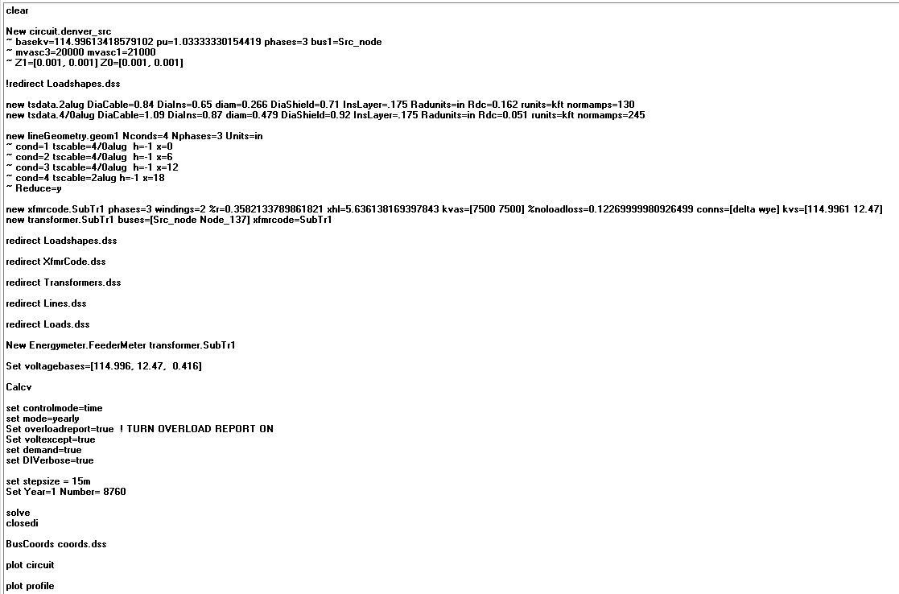

This is a picture that shows the original code the competition gave us. Specifically, this is where all the simulation happens. There are other codes that define all the lines and transformers, but here is where everything unifies, and the simulations happened. When this simulation is run the program will give us a drawing of all the lines that are created and connected on the circuit. Another thing that the base program will give us is a plot of Voltage vs Distance.

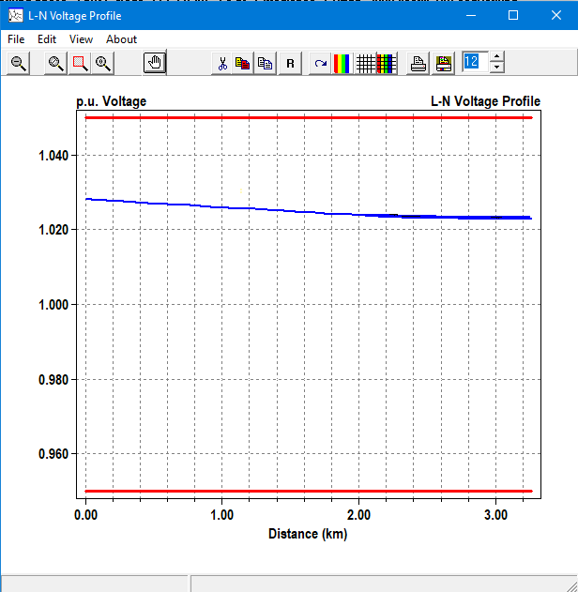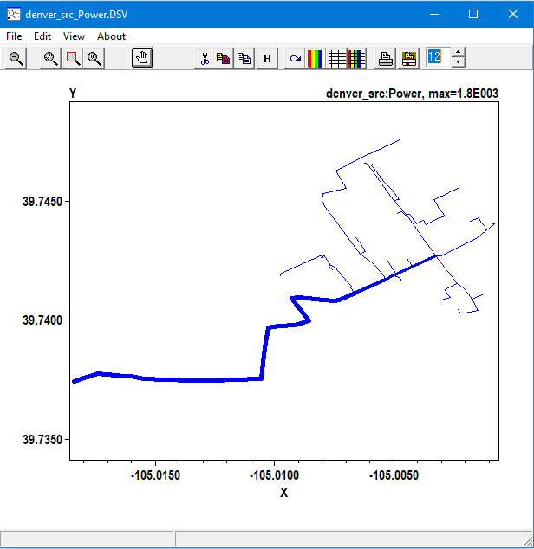

Graph 1: Voltage vs Distance Graph 2: lines created in OpenDss

On Graph 1 we can appreciate how the voltage behaves when we consider the distance. In the graph the plot the voltage drops when the distance is increased. This is because in the base code, when all the lines connect and the circuit is created, the distances that the voltage must travel all far enough to make the voltages drop. On Graph 2 we can appreciate how all the lines on the base code are connected to create the circuit. This simulates the lines in wires that are currently in use in Auraria. The OpenDss Team must take this to account when creating or modifying the lines or making new ones. If new ones are created, we must connect them to existing ones or to a transformer that connects with the existing lines. Another important thing to consider ion Graph 2 is that there are thicker lines with more deep blue than others. This is because there is more current passing through those lines compared to the more light and skinny blue lines.

For next week, the OpenDss team gave me the task to look for information on how to connect a battery and a smart inverter to the OpenDss circuit. What is info we will start the connection to the PV systems that the Design team made. Is important to know that there are some values to work with and the design team is currently working on some changes to the PV system. But we are working to make everything faster and have almost everything ready so when the design team gives us the new PV system we are ready to connect and see the new simulation.